CS 305 Project One Template

Document Revision History

Version | Date | Author | Comments
1.0 | 09-16-2026 | Ashley Brewer

Client



Instructions
Submit this completed vulnerability assessment report. Replace the bracketed text with the relevant information. In this report, identify your security vulnerability findings and recommend the next steps to remedy the issues you have found.

- Respond to the five steps outlined below and include your findings.
- Respond using your own words. You may also include images or supporting materials. If you include them, make certain to insert them in the relevant locations in the document.
- Refer to the Project One Guidelines and Rubric for more detailed instructions about each section of the template.

Developer
Ashley Brewer

1. Interpreting Client Needs
Determine your client’s needs and potential threats and attacks associated with the company’s application and software security requirements. Consider the following questions regarding how companies protect against external threats based on the scenario information:

- What is the value of secure communications to the company?
- Are there any international transactions that the company produces?
- Are there governmental restrictions on secure communications to consider?
- What external threats might be present now and in the immediate future?
- What modernization requirements must be considered, such as the role of open-source libraries and evolving web application technologies?

As a company managing highly sensitive financial information, Artemis Financial should put secure communications as one of the highest priorities. Their clients trust them with their personal confidential information, so it is Artemis Financial’s duty to protect that information.
Because Artemis Financial has clients around the world, its RESTful API will need to handle international transactions. International financial consulting requires secure data pipelines that span multiple jurisdictions, making encryption a baseline necessity. And data passing through international internet exchange points faces higher risks of state-sponsored interception or corporate espionage, requiring end-to-end transport layer security.
Operating globally means there are multiple governmental regulations regarding secure data transmission and cryptography. There are financial regulations that require safeguards for sensitive data, data privacy frameworks that require Artemis to protect user data under penalty of fines, and some jurisdictions restrict the strength of encryption algorithms that are used commercially so Artemis will need to verify global compliancy.
As a high-value financial target, Artemis faces many external threats. Attackers scan public APIs for vulnerabilities, so there is the immediate and constant threat of API injections and exploits. Without rigorous HTTPS/TLS enforcement, attackers on public or compromised networks can intercept, read, or alter data mid-transit. Attackers will also target authentication endpoints to compromise user accounts. And there is always the threat of ransomware through out-of-date web servers or open-sourced dependencies.
Relying on open-source frameworks speeds up development but introduces Software Supply Chain Risk. Artemis Financial must integrate continuous software composition analysis to detect public vulnerabilities and exposures embedded in third-party libraries. And RESTful architectures rely on stateless JSON exchanges, moving security boundaries from network perimeter to individual API points, and modern architectures require token-based authentication and strict structural input validation.

2. Areas of Security
Refer to the vulnerability assessment process flow diagram. Identify which areas of security apply to Artemis Financial’s software application. Justify your reasoning for why each area is relevant to the software application.

- Input validation
As a web-based RESTful API, Artemis Financial accepts user parameters via URLs, JSON, and form field. Without strict input validation, malicious data can bypass defenses. Implementation of constraints prevents injection attacks and ensures that the financial application logically valid data.
- APIs
The primary architecture of Artemis Financial’s modern software layer is a RESTful web API, and secure API interaction dictate how endpoints are exposed, authenticated, and restricted. Securing layer ensures proper access control policies, prevents broken object-level authorization, and ensures external systems can’t extract sensitive payloads.
- Cryptography
Because Artemis Financial handles highly classified data, cryptography is required both in transit and at rest. Weak cryptographic primitives, like obsolete hashing algorithms, could lead to a data breach.
- Client/Server
Artemis Financial operates in a distributed cloud or web environment where data continuously transfers between remote clients and a centralized financial database server. Security is necessary to establish proper session management, secure resource sharing configurations, and network-level protection.
- Code Error
Raw exception leaks, verbose stack traces, and unhandled runtime database errors expose internal systems, database schemas, and directory configurations to attackers. Secure error handling ensures that the application suppresses detailed internal framework behavior on the client-side while safely logging details into secure, internal auditor logs.
- Code Quality
Secure coding standards prevent logical oversights like memory leaks, resource exhaustion, and unpatched vulnerabilities. Static analysis metrics guarantee that the logic enforces role-based access control and that baseline components protect against functional exploits.
- Encapsulation
Encapsulation establishes private, controlled access boundaries around internal Java data structures. It prevents an attacker or unexpected execution thread from modifying financial parameters directly, forcing all state transitions through strict validation methods.

3. Manual Review
Continue working through the vulnerability assessment process flow diagram. Identify all vulnerabilities in the code base by manually inspecting the code.

- CRUDController.java has a vulnerability in input validation. The business_name request parameter is passed directly without validation, so attackers can manipulate queries.
- CRUDController.java also has an API vulnerability. The /read endpoint uses a generic @RequestMapping, leaving the endpoint vulnerable to unexpected HTTP verbs like POST or DELETE, expanding the API’s attack surface.
- customer.java has an encapsulation vulnerability. The account_balance field does not have a visibility modifier, so any class inside that package can directly modify a user’s account balance.
- customer.java also has a vulnerability in input validation. The deposit method accepts unvalidated integers, so attackers can input negative amounts to withdraw funds or trigger overflows in balances.
- DocData.java has a cryptographic vulnerability. Database root passwords are exposed in clear text, so anyone with repository access can compromise internal databases.
- DocData.java also has a code error. The printStackTrace() exceptions are written directly to standard error logs, disclosing internal database configurations and framework directory tracks to external attackers.
- GreetingController.java has a vulnerability in input validation. Unsanitized parameters are injected directly into a view template, so attackers can execute malicious scripts inside other active browser sessions.
- RestServiceApplication.java has an API vulnerability. The application is missing an identity provider, so all REST endpoints are exposed to the open web.

4. Static Testing
Run a dependency check on Artemis Financial’s software application to identify all security vulnerabilities in the code. Record the output from the dependency-check report. Include the following items:

- The names or vulnerability codes of the known vulnerabilities
- A brief description and recommended solutions provided by the dependency-check report
- Any attribution that documents how this vulnerability has been identified or documented previously

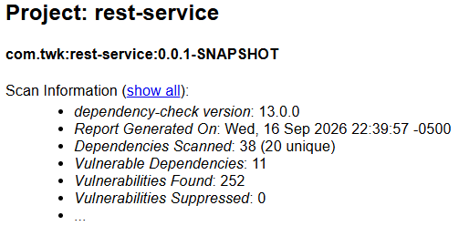
There are 38 total dependencies, 11 vulnerable dependencies, and 252 total vulnerabilities. Spring and Tomcat-embed are the biggest security risks:
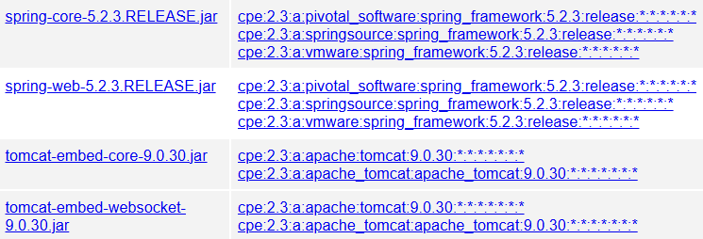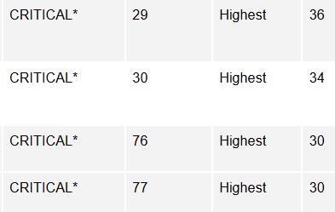

Spring-core 5.2.3: CVE 2022 22965 and Spring-web 5.2.3: CVE 2016 1000027 are critical severity as they have known vulnerabilities to remote code execution when used for Java deserialization of untrusted data. It is recommended to update the Spring Framework to version 5.3.33 or higher:
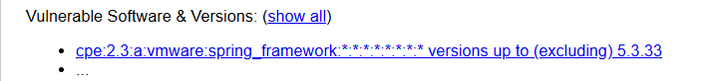

Tomcat-embed-core 9.0.30: CVE 2020 1938 and tomcat-embed-websocket 9.0.30: CVE 2020 1938 are critical severity as they are known to give Apache JServ Protocol higher trust than other HTTP connections, which can be exploited. It is recommended to update Apache Tomcat configurations to 9.0.98 or higher:

5. Mitigation Plan
Interpret the results from the manual review and static testing report. Then identify the steps to mitigate the identified security vulnerabilities for Artemis Financial’s software application.

First, we need to implement centralized API access controls. We can do this by adding spring-boot-starter-security framework to RestServiceApplication.java. This will close all public endpoints and transition the API structure away from unauthenticated connections to token-based authentication.
Next, we need to upgrade framework dependencies. We can modify the pom.xml to upgrade the parent platform framework. This will upgrade the Spring Boot platform, resolving many known vulnerabilities.
Then, we need to refactor the defensive source code. We can restructure customer.java and myDateTime.java to enforce explicit private modifiers on all sensitive fields. We can also apply structural input constraints in CRUDController.java and GreetingController.java to intercept and sanitize user query parameters. And we can remove hardcoded plaintext connection credentials from DocData.java to store all sensitive configuration variables in environment variables or vault registries.
Lastly, we need error management. We can refactor try-catch structures in controller files, using internal, structured logging frameworks to hide stack traces and internal schema parameters from public web clients.

